Thoroughly read the objectives, instructions and requirements of this project and then use suitable electronic technology tools to construct or solve the project.

Submit both your program source code, with your name, date and course information in the heading portion of your code, as well as the required output(s).

**Project** (Seminar Scheduling) **100 Points _____ *score***

Sedgwick Seminar Services, a new company that offers technology - training seminars to clients in the technology industry, has hired you as a DBA to design a database that contains information on its seminars and that tracks / maintains / updates other related information.

The following datasheet lists information regarding the first group of students who registered for upcoming seminars. The students are listed according to the order in which they registered.

|  |  |  |  |  |  |  |  |  |  |
| --- | --- | --- | --- | --- | --- | --- | --- | --- | --- |
| **Order** | **Order Date** | **Last Name** | **First Name** | **ID** | **Topic** | **Type** | **Number** | **Fee** | **Discount** |
| 101 | 11/10/11 | Stevens | Steve | S1000 | UNIX | C | 7 | $ 200 | 0 % |
| 102 | 11/10/11 | Richards | Roger | R1000 | Visual Basic | B | 2 | $ 150 | 0 % |
| 103 | 11/10/11 | Andrews | Arthur | A1000 | Windows | A | 1 | $ 125 | 0 % |
| 104 | 11/11/11 | Jeffries | Joyce | J1000 | Finance | B | 4 | $ 150 | 10 % |
| 105 | 11/11/11 | Connors | Carol | C1000 | Windows | A | 5 | $ 125 | 0 % |
| 106 | 11/11/11 | Tance | Terrence | T1000 | Marketing | C | 6 | $ 200 | 0 % |
| 107 | 11/11/11 | Benson | Bobby | B1000 | UNIX | C | 7 | $ 200 | 10 % |
| 108 | 11/12/11 | Stevens | Steve | S1000 | Windows | A | 5 | $ 125 | 0 % |
| 109 | 11/12/11 | Boyce | Barbara | B1001 | Visual Basic | A | 3 | $ 125 | 0 % |
| 110 | 11/12/11 | Norwood | Norman | N1000 | Visual Basic | B | 2 | $ 150 | 0 % |
| 111 | 11/12/11 | Munson | Michael | M1000 | Visual Basic | A | 3 | $ 125 | 20 % |
| 112 | 11/12/11 | Penn | Peter | P1000 | UNIX | C | 7 | $ 200 | 0 % |
| 113 | 11/12/11 | Bartlett | Betty | B1002 | Finance | B | 4 | $ 150 | 10 % |
| 114 | 11/12/11 | Lords | Lance | L1000 | Marketing | C | 6 | $ 200 | 0 % |
| 115 | 11/13/11 | Daniels | Denise | D1000 | Marketing | C | 6 | $ 200 | 0 % |
| 116 | 11/13/11 | Benson | Bobby | B1000 | Visual Basic | B | 2 | $ 150 | 10 % |
| 117 | 11/13/11 | Landers | Louise | L1001 | Finance | B | 4 | $ 150 | 0 % |
| 118 | 11/13/11 | Orion | Orlando | O1000 | Windows | A | 1 | $ 125 | 0 % |
| 119 | 11/14/11 | Reynolds | Randy | R1001 | Finance | B | 4 | $ 150 | 20 % |
| 120 | 11/14/11 | Summers | Sandy | S1001 | Visual Basic | A | 3 | $ 125 | 0 % |

The above datasheet includes the following:

(1) The student order number, which is used as an invoice number for billing purposes.

(2) The order date, which is used as an invoice date for billing purposes.

(3) The student’s last name.

(4) The student’s first name.

(5) The student’s unique identification number.

(6) The topic (title) of the seminar.

(7) The type or level of difficulty of the seminar, where A indicates a beginner’s seminar, B indicates an intermediate seminar and C designates an advanced seminar.

(8) The seminar number code refers to the unique scheduling order of the various seminars. This code number identifies the individual seminars as they are created.

(9) The fee (tuition) associated with the seminar where type A seminars have a fee of

$ 125, type B seminars have a fee of $ 150 and type C seminars have a fee of $ 200 .

(10) Certain clients of Sedgwick will have a 10 % or a 20 % seminar discount.

The following datasheet lists information regarding the first group of seminars that have been scheduled. The seminars are listed according to the order in which they were created.

|  |  |  |  |  |  |  |  |
| --- | --- | --- | --- | --- | --- | --- | --- |
| **Number** | **Topic** | **Type** | **Instructor** | **Date** | **Time** | **Fee** | **Room** |
| 1 | Windows | A | Pappas | 03/20/12 | 9:00 am | $ 125 | 300 |
| 2 | Visual Basic | B | Stein | 03/20/12 | 12:00 pm | $ 150 | 400 |
| 3 | Visual Basic | A | Stein | 03/24/12 | 9:00 am | $ 125 | 500 |
| 4 | Finance | B | Pappas | 03/24/12 | 12:00 pm | $ 150 | 500 |
| 5 | Windows | A | Logan | 03/26/12 | 6:00 pm | $ 125 | 400 |
| 6 | Marketing | C | Manners | 03/28/12 | 9:00 am | $ 200 | 600 |
| 7 | UNIX | C | Morley | 04/04/12 | 12:00 pm | $ 200 | 300 |

The above datasheet includes the following:

(1) The seminar number code refers to the unique scheduling order of the various seminars. This code number identifies the individual seminars as they are created.

(2) The topic ( title ) of the seminar.

(3) The type or level of difficulty of the seminar, where A indicates a beginner’s seminar, B indicates an intermediate seminar and C designates an advanced seminar.

(4) The instructor’s last name.

(5) The date of the seminar.

(6) The time of the seminar. Seminars are scheduled in two - hour blocks and begin at

9:00 am, 12:00 pm, 3:00 pm and 6:00 pm.

(7) The fee (tuition) associated with the seminar where type A seminars have a fee of

$ 125, type B seminars have a fee of $ 150 and type C seminars have a fee of $ 200 . Certain clients of Sedgwick will have a 10 % or a 20 % seminar discount.

(8) The rooms assigned to the particular seminar. The available rooms include: 100, 200, 300, 400, 500 and 600.

The available instructors and their areas of expertise are listed in the datasheet below. Level I instructors are assigned to beginning seminar’s only, level II instructors can

be assigned any seminar except advanced and level III instructors can instruct any seminar.

|  |  |  |  |
| --- | --- | --- | --- |
| **Employee ID** | **Last Name** | **First Name** | **Level** |
| 101 | Morley | Michele | III |
| 102 | Pappas | Peter | III |
| 103 | Stein | Steve | III |
| 104 | Logan | Lance | I |
| 105 | Arthur | Anthony | II |
| 106 | Leonard | Lorraine | II |
| 107 | Zalman | Zollie | III |
| 108 | Bronson | Beatrice | III |
| 109 | Manners | Monique | II |
| 110 | Richards | Randy | I |

**Part A. Give SQL statements and the resulting output to extract the following information. Place a copy of the code and the output below each requirement.**

1) The number of students per topic.

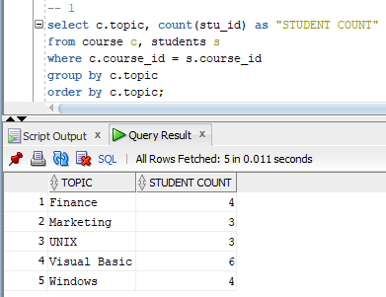

2) The list of students each instructor has.

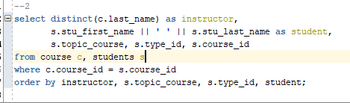

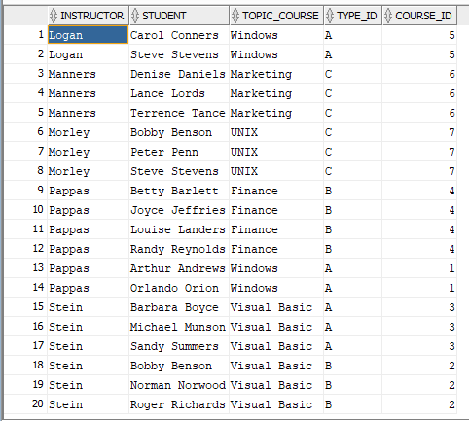

3) The total number of students each instructor has.

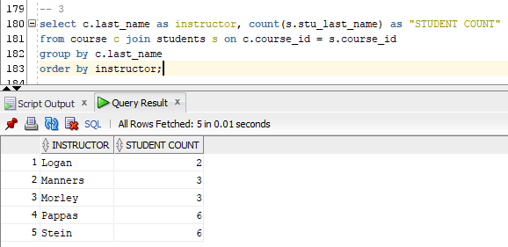

4) The actual price each student must pay for their seminar.

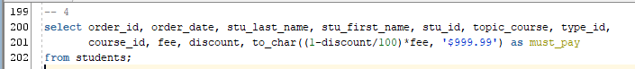

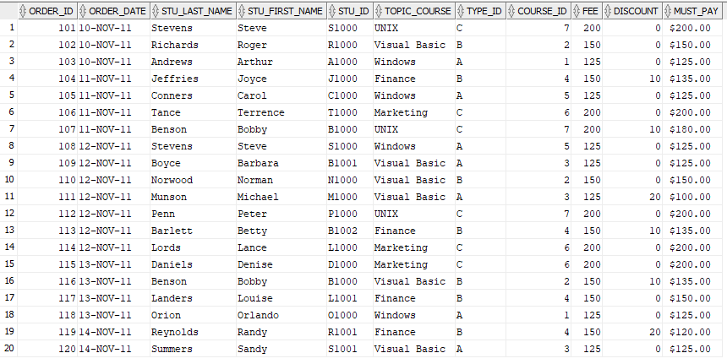

5) The total fees collected for each course.

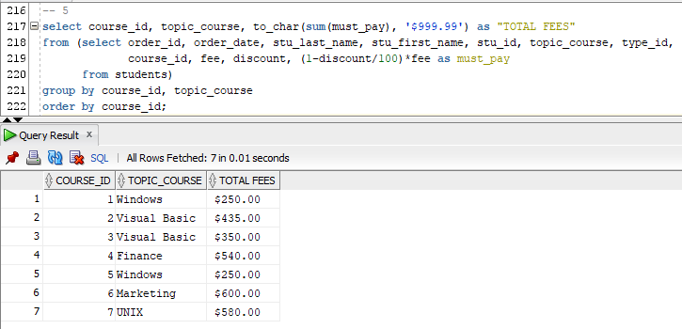

6) The grand total in fees collected by Sedgwick.

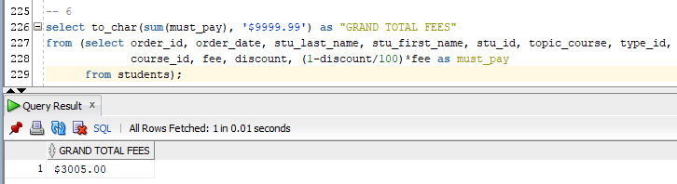

7) The courses that Level I instructors cannot teach. [Hint: Type A would be taught only by Level I Instructors]

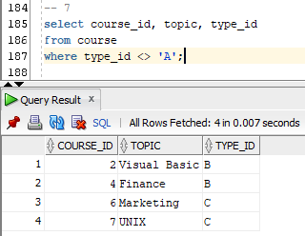

**Part B. Using PL/SQL block statements perform the following. Place a copy of the code and the output below each requirement.**

1) Update the table containing the student seminar information to include a 5% increase in fees for all courses.

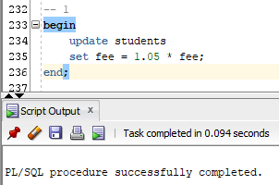

**Note that the resulting fees are rounded to the nearest whole number since the fee field is defined as NUMBER(5).**

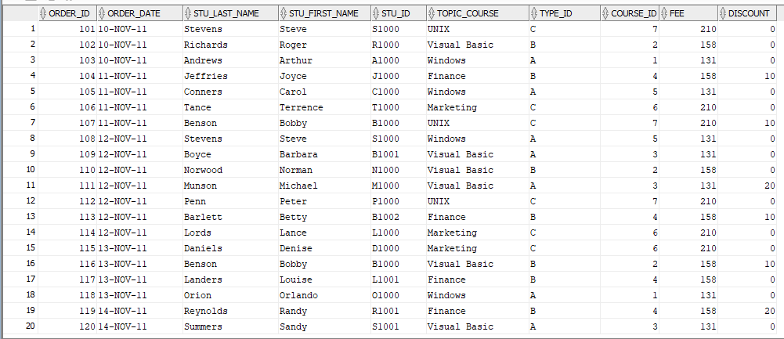

2) Insert data for a new course called SQL (type C, number=8, fee $250, no discounts) to be taught by Harry Hacker, a Level III instructor, employee ID=112. Kit Katchup will take the seminar. Her order number is 121 with an order date being 11/13/05. She has been assigned a student id number as K1001.

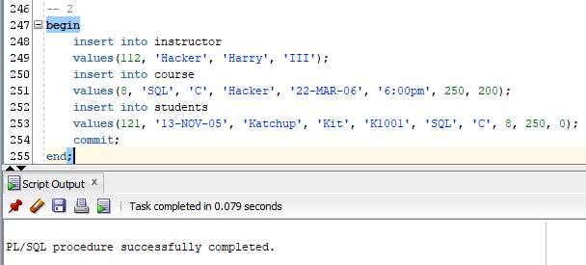

**Instructor table:**

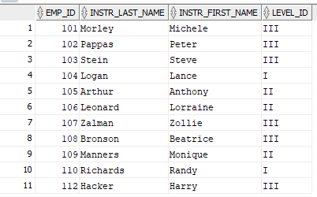

**Course table:**

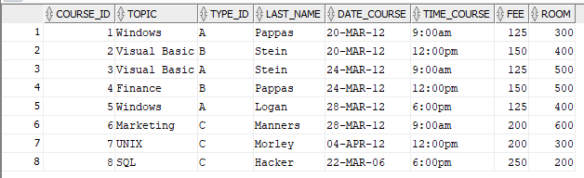

**Students table:**

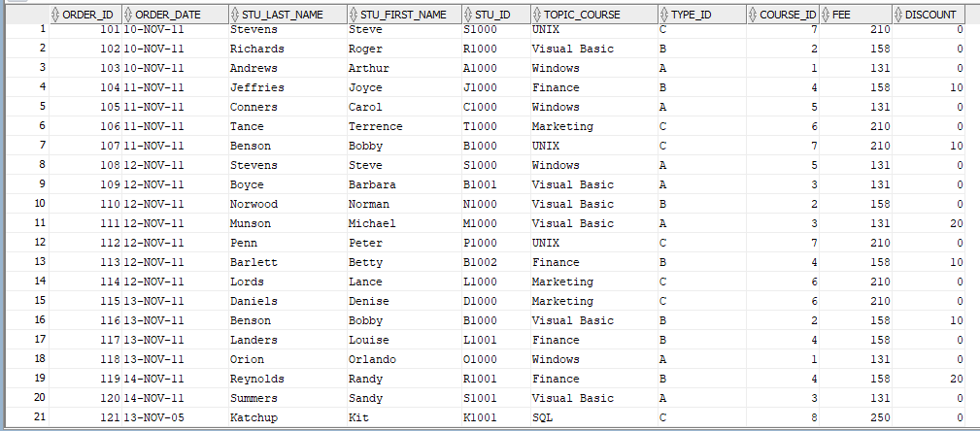

3) Create a function that will ask for the instructor’s last name and will output the total number of students that were assigned to that instructor.

Make sure that all reports have proper formatting and a header entitled “Sedgwick Seminar Services”, if the system allows formatting. Otherwise, ignore.

**Function creation:**

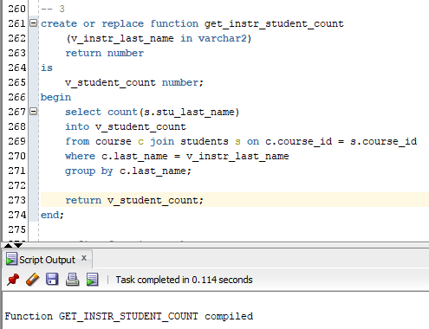

**Query test:**

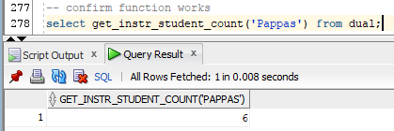

**Calling the function with a procedure:**

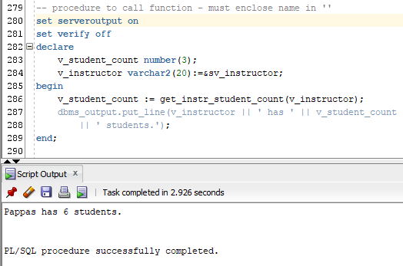

**Part C. Create code for the Other Database Objects listed below. Place a copy of the code and the output below each requirement.**

1. Create a view for each instructor that allows only the instructor’s data to be observed.

**The other views are only coded differently in that they have a different isntr_last_name.**

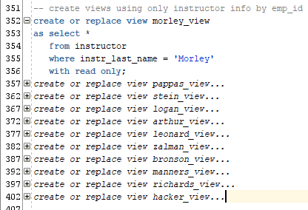

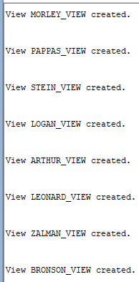

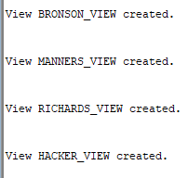

**select * from each respective view:**

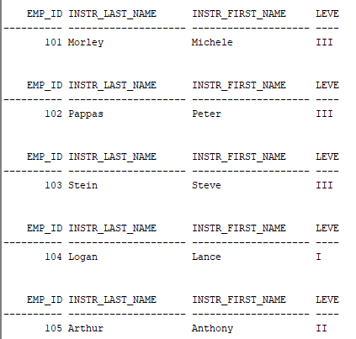

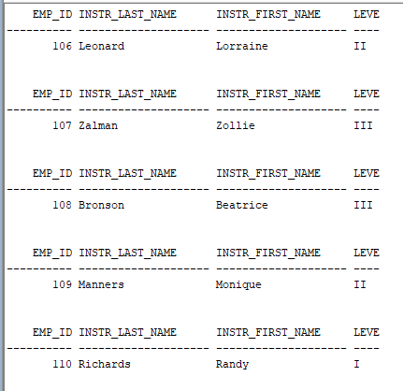

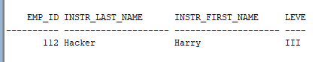

2) Create a sequence for the order number and for the topic number.

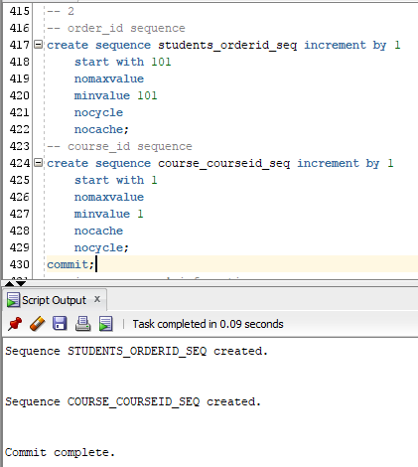

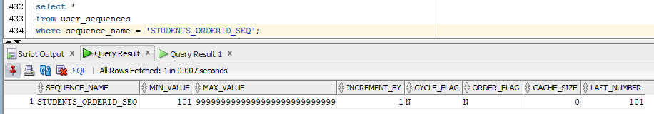

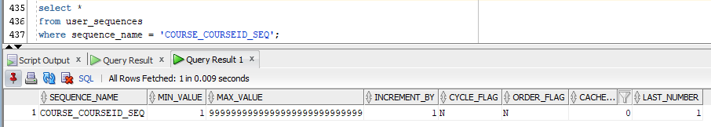

3) Explain why an index should or should not be created for the column “type”.

**An indexd should not be created for the column “type” because the table is small and the column does not have a wide range of values. The column only has three possible values: A, B, or C.**